Greetings from Millington,

CDR Hilliard: Opening Remarks:

Good afternoon and welcome to the November OP Drumbeat TEAMS series. This month we will be talking about “Back to Basics” with our guest speaker Mrs. Heather Jacobs, the Military Liaison for Director, Acquisition Talent Management (DATM). Thank you for providing training on this important topic. First, I’ll turn it over to the Career Counselor for updates.

LCDR Mays: Career Counselor Updates:

1. 2025 OP Roadshow dates have been released to the Community. You can find them either on the eSUPPO app or in the latest OP Drumbeat edition. First on the list is Stuttgart and Naples in December. For questions, please reach out to the Career Counselor and we look forward to seeing the team on the road.

I’ll turn it over to CDR Hilliard to introduce our special guest speaker.

Guest Speakers: Mrs. Heather Jacobs (DAU Military Liaison at the Pentagon under DATM)

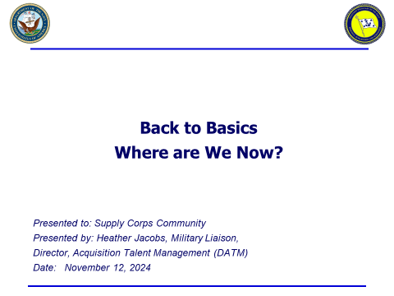

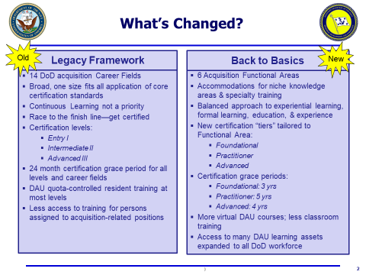

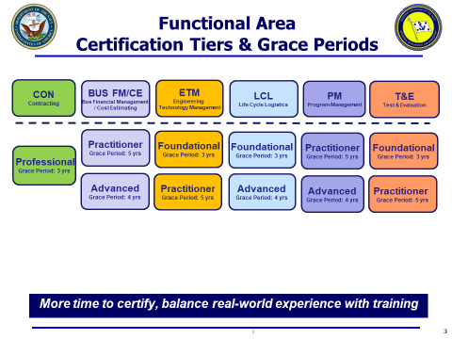

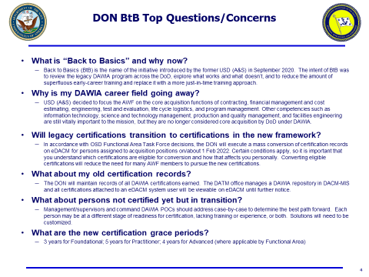

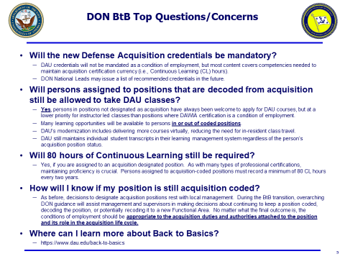

_____________________________________________________________________________________

Mrs. Heather Jacobs Remarks:

The “Back to Basics” shift was to prioritize real world experience and put less emphasis on finishing the classes as fast as possible. Our big push was to focus on what have you done in the career field. One of the major changes we made with “Back to Basics” was allowing individuals to apply for credit after leaving the billet. This helps in everyone getting their full credit even if they left the coded billet they were originally in.

Another important topic to bring up is that, if you are in a coded billet, you will have a DAU POC to help with any DAU issues. You can find this DAU POC under you DAU account when you log in. DAU doesn’t reflect that you’re in a code billet until 30-45 days after you have checked in to your new command, but this doesn’t mean you can’t create an account on the DAU/eDACM.

Important Links:

[Certification & Core Plus Development Guides](https://icatalog.dau.edu/onlinecatalog/CareerLvl.aspx)

[Defense Acquisition Workforce Position Category Descriptions (PDC)](https://icatalog.dau.edu/onlinecatalog/pcd.aspx)

_____________________________________________________________________________________

Q & A Session:

Q1. LCDR Meyer: Can you provide the reason why there is only one level of certification for contracting and the thought process between only having the one level?

A1. Mrs. Jacobs: For contracting, the thought process was what real-world experience do you have on top of getting the actual certification. Big picture, what have you done in the contracting world. From a big DOD perspective, they wanted contracting to follow the National Contracting Management Standard. This was so a qualification in contracting was seen as more of a professional certification instead of just a DAU certification.

Q2. LCDR Wallin: Will the detailers help those working towards a BFM certification? This is definitely a two tour requirement.

A2. CAPT Risley: For BFM, this will be handled on a case-by-case basis. If you current billet and personal timeline allows for you to extend, the detailers will work to support but there may be instances where the community will need to rotate you to a follow on tour. For more specific situations please reach out to Career Counselor or Pit Boss for guidance.

Q3. LCDR McLaury: Will a 1309 SUBSPEC earned at NPS transition into a different SUBSPEC, like ENG. tech management?

A3. CDR Hilliard: 1309 will remain as our SUBSPEC we use to manage LOG IT, DAWIA AQDs associated with billets where 1309 is needed can vary - confirming what I was just commenting on - some are Program Management (AAN) or Life Cycle Logistics (ALN).